TASK 4.1
PROGRAM
class Solution {
public boolean halvesAreAlike(String s) {
int count = 0;
int n = s.length();
for (int i = 0; i < n / 2; i++) {
if (isVowel(s.charAt(i))) {
count++;
}
if (isVowel(s.charAt(i + n / 2))) {
count--;
}
}
return count == 0;
}
private boolean isVowel(char ch) {
return ch == 'a' || ch == 'e' || ch == 'i' ||
ch == 'o' || ch == 'u' ||
ch == 'A' || ch == 'E' || ch == 'I' ||
ch == 'O' || ch == 'U';
}
}
OUTPUT:
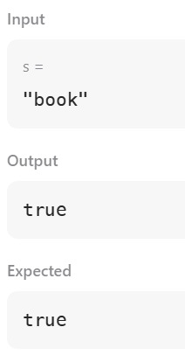
TASK 4.2
PROGRAM
import java.util.*;
import java.lang.*;
import java.io.*;
class Codechef
{
public static void main (String[] args) throws java.lang.Exception
{
Scanner sc = new Scanner(System.in);
int T = sc.nextInt();
while (T-- > 0)
{
String s = sc.next();
int n = s.length();
int[] freq = new int[26];
for (int i = 0; i < n / 2; i++)
{
freq[s.charAt(i) - 'a']++;
}
for (int i = (n + 1) / 2; i < n; i++)
{
freq[s.charAt(i) - 'a']--;
}
boolean lapindrome = true;
for (int i = 0; i < 26; i++)
{
if (freq[i] != 0)
{
lapindrome = false;
break;
}
}
if (lapindrome)
System.out.println("YES");
else
System.out.println("NO");
}
sc.close();
}
}
OUTPUT:
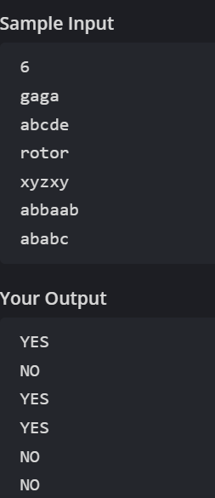

TASK 4.3
PROGRAM:
import java.io.*;
import java.math.*;
import java.security.*;
import java.text.*;
import java.util.*;
import java.util.concurrent.*;
import java.util.function.*;
import java.util.regex.*;
import java.util.stream.*;
import static java.util.stream.Collectors.joining;
import static java.util.stream.Collectors.toList;
class Result {
/*
* Complete the 'compareTriplets' function below.
*
* The function is expected to return an INTEGER_ARRAY.
* The function accepts following parameters:
* 1. INTEGER_ARRAY a
* 2. INTEGER_ARRAY b
*/
public static List<Integer> compareTriplets(List<Integer> a, List<Integer> b) {
int alice = 0;
int bob = 0;
for (int i = 0; i < 3; i++) {
if (a.get(i) > b.get(i)) {
alice++;
}
else if (a.get(i) < b.get(i)) {
bob++;
}
}
return Arrays.asList(alice, bob);
}
}
public class Solution {
public static void main(String[] args) throws IOException {
BufferedReader bufferedReader = new BufferedReader(new InputStreamReader(System.in));
BufferedWriter bufferedWriter = new BufferedWriter(new FileWriter(System.getenv("OUTPUT_PATH")));
List<Integer> a = Stream.of(bufferedReader.readLine().replaceAll("\\s+$", "").split(" "))
.map(Integer::parseInt)
.collect(toList());
List<Integer> b = Stream.of(bufferedReader.readLine().replaceAll("\\s+$", "").split(" "))
.map(Integer::parseInt)
.collect(toList());
List<Integer> result = Result.compareTriplets(a, b);
bufferedWriter.write(
result.stream()
.map(Object::toString)
.collect(joining(" "))
+ "\n"
);

bufferedReader.close();
bufferedWriter.close();
}
}
OUTPUT:
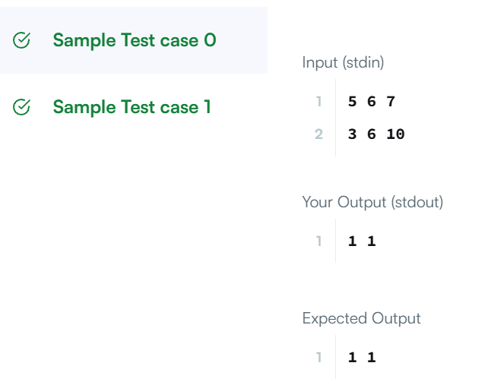
TASK 4.4
PROGRAM
class Solution {
public boolean containsDuplicate(int[] nums) {
HashSet<Integer> set = new HashSet<>();
for (int num : nums) {
if (set.contains(num)) {
return true;
}
set.add(num);
}
return false;
}
}
OUTPUT:
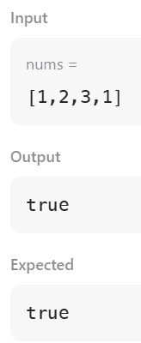

TASK 4.5
PROGRAM:
import java.io.*;
import java.math.*;
import java.security.*;
import java.text.*;
import java.util.*;
import java.util.concurrent.*;
import java.util.function.*;
import java.util.regex.*;
import java.util.stream.*;
import static java.util.stream.Collectors.joining;
import static java.util.stream.Collectors.toList;
class Result {
/*
* Complete the 'timeConversion' function below.
*
* The function is expected to return a STRING.
* The function accepts STRING s as parameter.
*/
public static String timeConversion(String s) {
int hour = Integer.parseInt(s.substring(0, 2));
if (s.endsWith("AM")) {
if (hour == 12) {
hour = 0;
}
} else {
if (hour != 12) {
hour += 12;
}
}

return String.format("%02d", hour) + s.substring(2, 8);
}
}
public class Solution {
public static void main(String[] args) throws IOException {
BufferedReader bufferedReader = new BufferedReader(new InputStreamReader(System.in));
BufferedWriter bufferedWriter = new BufferedWriter(new FileWriter(System.getenv("OUTPUT_PATH")));
String s = bufferedReader.readLine();
String result = Result.timeConversion(s);
bufferedWriter.write(result);
bufferedWriter.newLine();
bufferedReader.close();
bufferedWriter.close();
}
}
OUTPUT:
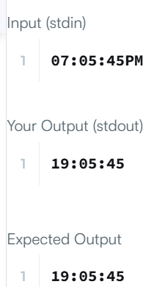

TASK 4.6
PROGRAM:
class Solution {
public void moveZeroes(int[] nums) {
int j = 0;
for (int i = 0; i < nums.length; i++) {

if (nums[i] != 0) {
int temp = nums[i];
nums[i] = nums[j];
nums[j] = temp;
j++;
}
}
}
}
OUTPUT:
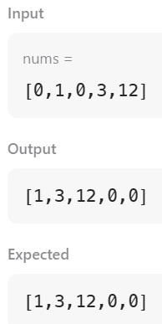
TASK 4.7
PROGRAM :
import java.util.*;
class Student {
private int id;
private String fname;
private double cgpa;
public Student(int id, String fname, double cgpa) {
this.id = id;
this.fname = fname;
this.cgpa = cgpa;
}
public int getId() {
return id;
}
public String getFname() {
return fname;
}
public double getCgpa() {
return cgpa;
}
}
public class Solution {
public static void main(String[] args) {
Scanner in = new Scanner(System.in);
int testCases = Integer.parseInt(in.nextLine());
List<Student> studentList = new ArrayList<Student>();
while (testCases > 0) {
int id = in.nextInt();
String fname = in.next();
double cgpa = in.nextDouble();
Student st = new Student(id, fname, cgpa);
studentList.add(st);
testCases--;
}
Collections.sort(studentList, new Comparator<Student>() {
public int compare(Student s1, Student s2) {
if (s1.getCgpa() != s2.getCgpa()) {
return Double.compare(s2.getCgpa(), s1.getCgpa());
}
if (!s1.getFname().equals(s2.getFname())) {
return s1.getFname().compareTo(s2.getFname());
}
return Integer.compare(s1.getId(), s2.getId());
}
});
for (Student st : studentList) {
System.out.println(st.getFname());
}
}
}
OUTPUT:
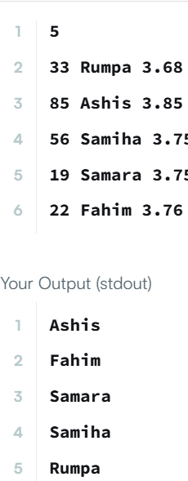

TASK 4.8
PROGRAM
class Solution {
public int[][] transpose(int[][] matrix) {
int rows = matrix.length;
int cols = matrix[0].length;
int[][] result = new int[cols][rows];
for (int i = 0; i < rows; i++) {
for (int j = 0; j < cols; j++) {
result[j][i] = matrix[i][j];
}
}
return result;
}
}
OUTPUT:
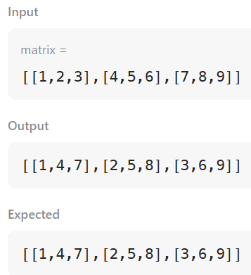

TASK 4.9
PROGRAM:
class Solution {
public int[][] matrixBlockSum(int[][] mat, int k) {
int m = mat.length;
int n = mat[0].length;
int[][] prefix = new int[m + 1][n + 1];
for (int i = 0; i < m; i++) {
for (int j = 0; j < n; j++) {
prefix[i + 1][j + 1] =
mat[i][j]
+ prefix[i][j + 1]
+ prefix[i + 1][j]
- prefix[i][j];
}
}
int[][] answer = new int[m][n];
for (int i = 0; i < m; i++) {
for (int j = 0; j < n; j++) {
int r1 = Math.max(0, i - k);
int c1 = Math.max(0, j - k);
int r2 = Math.min(m - 1, i + k);
int c2 = Math.min(n - 1, j + k);
answer[i][j] =
prefix[r2 + 1][c2 + 1]
- prefix[r1][c2 + 1]
- prefix[r2 + 1][c1]
+ prefix[r1][c1];
}
}
return answer;
}
}
OUTPUT:
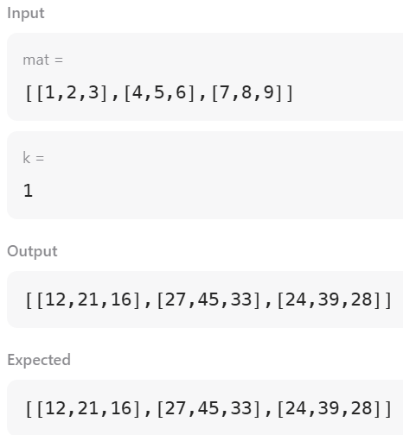

TASK 4.10
PROGRAM:
import java.io.*;
import java.math.*;
import java.security.*;
import java.text.*;
import java.util.*;
import java.util.concurrent.*;
import java.util.function.*;
import java.util.regex.*;
import java.util.stream.*;
import static java.util.stream.Collectors.joining;
import static java.util.stream.Collectors.toList;
class Result {
/*
* Complete the 'matrixRotation' function below.
*
* The function accepts following parameters:
* 1. 2D_INTEGER_ARRAY matrix
* 2. INTEGER r
*/
public static void matrixRotation(List<List<Integer>> matrix, int r) {
int m = matrix.size();
int n = matrix.get(0).size();
int layers = Math.min(m, n) / 2;
for (int layer = 0; layer < layers; layer++) {
List<Integer> list = new ArrayList<>();
for (int j = layer; j < n - layer; j++) {
list.add(matrix.get(layer).get(j));
}
for (int i = layer + 1; i < m - layer; i++) {
list.add(matrix.get(i).get(n - layer - 1));
}
for (int j = n - layer - 2; j >= layer; j--) {
list.add(matrix.get(m - layer - 1).get(j));
}
for (int i = m - layer - 2; i > layer; i--) {
list.add(matrix.get(i).get(layer));
}
int rotation = r % list.size();
List<Integer> rotated = new ArrayList<>();
for (int i = rotation; i < list.size(); i++) {
rotated.add(list.get(i));
}
for (int i = 0; i < rotation; i++) {
rotated.add(list.get(i));
}
int k = 0;

for (int j = layer; j < n - layer; j++) {
matrix.get(layer).set(j, rotated.get(k++));
}
for (int i = layer + 1; i < m - layer; i++) {
matrix.get(i).set(n - layer - 1, rotated.get(k++));
}
for (int j = n - layer - 2; j >= layer; j--) {
matrix.get(m - layer - 1).set(j, rotated.get(k++));
}
for (int i = m - layer - 2; i > layer; i--) {
matrix.get(i).set(layer, rotated.get(k++));
}
}
for (List<Integer> row : matrix) {
for (int value : row) {
System.out.print(value + " ");
}
System.out.println();
}
}
public class Solution {
public static void main(String[] args) throws IOException {
BufferedReader bufferedReader = new BufferedReader(new InputStreamReader(System.in));
String[] firstMultipleInput = bufferedReader.readLine().replaceAll("\\s+$", "").split(" ");
int m = Integer.parseInt(firstMultipleInput[0]);
int n = Integer.parseInt(firstMultipleInput[1]);
int r = Integer.parseInt(firstMultipleInput[2]);
List<List<Integer>> matrix = new ArrayList<>();
IntStream.range(0, m).forEach(i -> {
try {
matrix.add(
Stream.of(bufferedReader.readLine().replaceAll("\\s+$", "").split(" "))
.map(Integer::parseInt)
.collect(toList())
);
} catch (IOException ex) {
throw new RuntimeException(ex);
}
});
Result.matrixRotation(matrix, r);
bufferedReader.close();
}
}
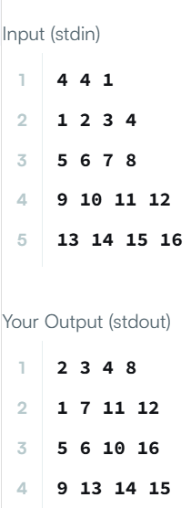
OUTPUT:

